**Sprint Planning**

Since Sprint 2, the following weeks at university were spent completing other assignments with earlier deadlines. Upon returning from the Christmas break, Michaela had been transferred to a different group. As a result, little progress has been made on the project and the team is now reduced by one member. The goal for Sprint 3 has therefore been to redefine roles within the group and attempt to catch up with the tasks left incomplete from Sprint 2.

The current Product Backlog and Sprint Backlog for Sprint 3 (with assigned tasks) are shown below:

|  |  |
| --- | --- |
| **PRODUCT BACKLOG** | **SPRINT BACKLOG** |
|  |  |
| **ASSIGNED TASKS** | |
| Abishek:   * Create website.   Alex:   * Develop basic menu/login screen. | Ann:   * Create AR store item objects. * Design images/QR codes to scan in store.   John:   * Create app login system. |

**Meetings/Discussions**

**MEETING (In University) – Wednesday 12th February (12/02/2020)**

**MEMBERS ATTENDED:**

Abishek, Alex, Ann, John

**WHAT HAS BEEN DONE SO FAR?**

* Ann has created some 3D models of store items, though when imported into Unity, the models lose their textures. It has been suggested that the textures must be exported separately and added to Unity as materials which can then be attached to the objects.
* Abishek has started creating a website for the product.

**ISSUES:**

* There has been no evidence of progress from Alex and John so far.

**MEETING OUTCOMES:**

* Ann will continue to work on her 3D models and will try to find a way to successfully import the textures into Unity along with the models.

**Sprint Review**

Below is the final board at the end of Sprint 3:

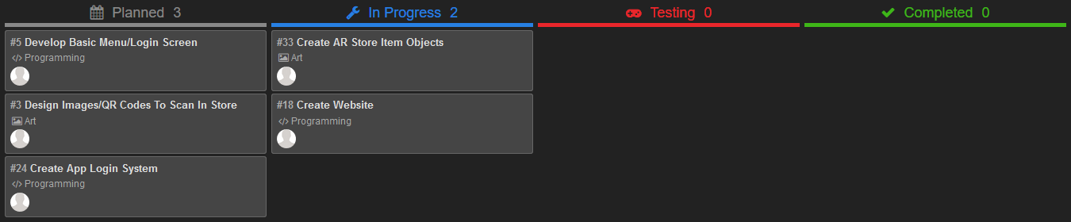

**WHAT BACKLOG ITEMS HAVE BEEN “DONE”?**

* None.

**WHAT BACKLOG ITEMS HAVE NOT BEEN “DONE” AND WHY?**

* Develop basic menu/login screen.
* Design images/QR codes to scan in store.
* Create app login system.
* Create AR store item objects.
* Create website.

The lack of progress and work completed on this Sprint has been due to a number of issues within the group including communication, attendance and other assignments.

**WHAT TO DO NEXT?**

The next Sprint is likely to be similar to this one in terms of the Sprint Backlog items. On tasks where work has been started, these will need to be completed by the assigned group members, whereas for the others, roles may need to be swapped around, as there are evidently issues that are causing this work to remain incomplete.

**Sprint Retrospective**

Both communication and attendance to meetings have now become severe issues within this project. There have been no messages over WhatsApp for the duration of this Sprint and some members have been absent for several university sessions now, meaning there has been little-to-no face-to-face communication. It is recognised that deadlines for other assignments has impeded the project, but the full team has been unable to meet and discuss how this could be worked around.